Module 2

# Lesson 5

1. Fan-out Wafer Level Package

The one difference between the flip chip package and the wafer level package is that the chip is connected to the solder balls through the RDL.

* First, we will pick and place the known good dies on a temporary carrier.
* Then we will add the molding compound to protect the chip.
* After that we will remove the temporary carrier to get a reconstituted wafer (chips on molding compound).

Now we need to prepare the RDL for that we will use coating of dielectric material and metal.

* First, we make a metal layer.
* Then add the dielectric layer and create grooves.
* After that we add another metal layer and pattern it. The pattern will be made by covering the grooves and making more.

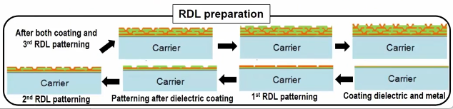Now you have to continue these steps until you have the desired number of layers. In this case we have three layers.

* We now put the prepared RDL on the reconstituted wafers.
* Then we attach the solder balls.
* After that we mark the wafer.
* Finally through the process of singulation we separate the individual chips.

If you have high pin count and low pitch then fan-out chip are the best for you.

Processing video

<https://drive.google.com/file/d/19Zxx-L-sjkz3ZFuM0WUFlRX46RfqTvaM/view?usp=sharing>